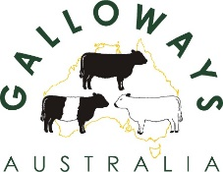
DNA APPLICATION FORM
Form 4 (21/11/24)
Contact Name: ---------------------------- Member ID: ---------------------------------
Please complete the Animal ID. Tick the boxes for the tests required. Sire and Dam only required if parentage verification needed
Animal Name | Animal Identity | Barcode on hair kit | Sire Trace  $27.50* | Sire Trace (+ Sire Verification)  $27.50* | Sire Trace (+ PV Verification)  $27.50* | Sire | Dam
As a condition of requesting any DNA test(s) from Zoetis you hereby acknowledge that Galloways Australia has the right to store and display the results for any such DNA test(s) in the Galloways Australia data base and via any other means e.g. website animal enquiry. Galloways Australia has the right to use the DNA information in both Research and Development, in the construction of genetic information and any other commercial outcomes.
*Fees are subject to change. Please check the Galloways Australia website for the current form/charge. See Submission Form 4A for payment method.
Signature: ------------------------------------------------------------------------ Date: --------------------------------------
SAMPLES NEED TO BE IN THE ZOETIS COLLECTION CARDS AND POSTED BACK WITH A COPY OF THIS FORM TO:
ZOETIS AUSTRALIA PTY LTD, P O BOX 75, BANYO, QLD 4014

